UML - UseCase Diagrams

Project: EasiLendar

The Very Best Meeting Planer

Creator:Nguyen Thi Luong

Last update: 12/05/2015

**Table of content**

1.Registration system 3

2. Using system 4

3. Appointment 5

4. Group meeting 6

5. Easischedule 7

6. Todo 8

7. Calendar 9

8. Share 10

9. Export 11

10. Help 13

11. Setting 14

# 1.Registration system

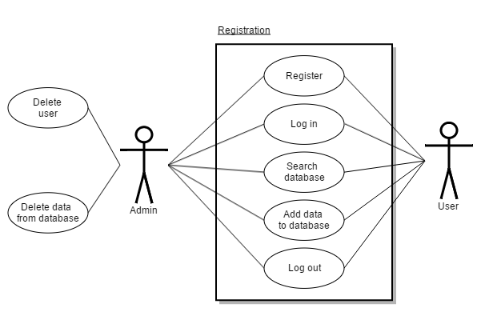

# 2. Using system

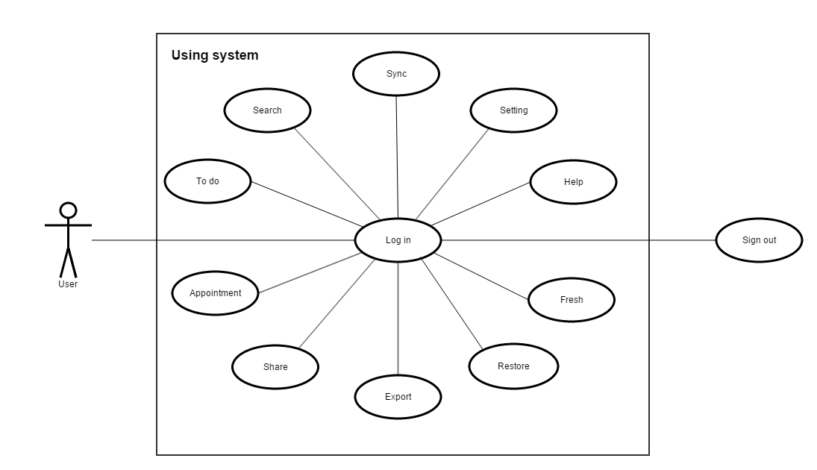

# 3. Appointment

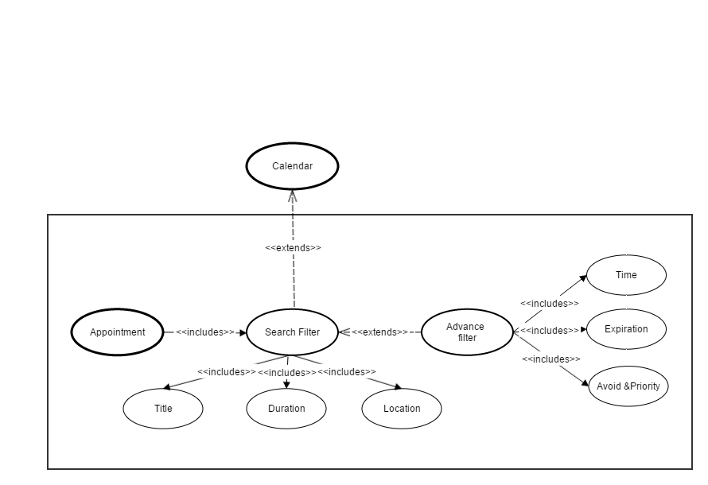

# 4. Group meeting

# 5. Easischedule

# 6. Todo

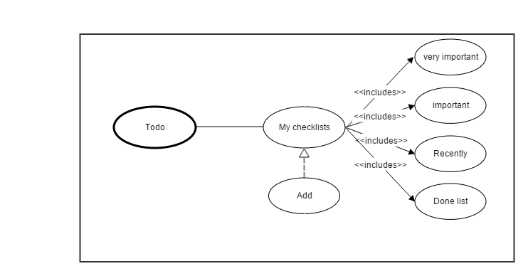

# 7. Calendar

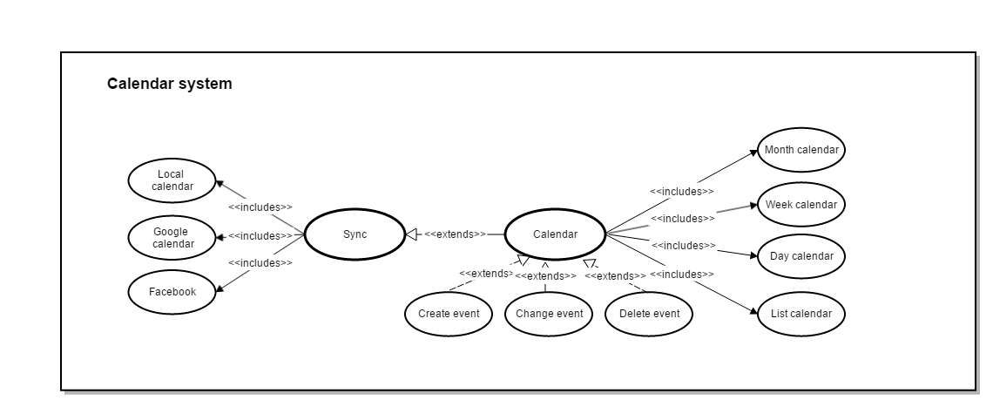

8. Share

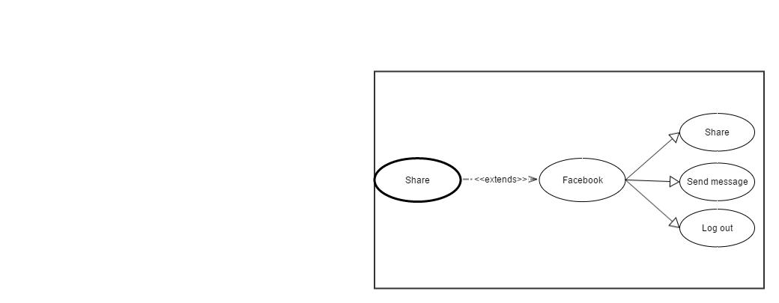

# 9. Export

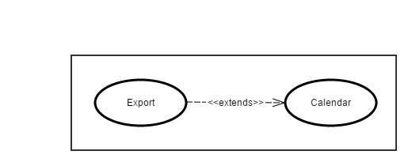

# 10. Help

# 11. Setting

